Manila Water Company
technical specification - REPORT

DID_S2P_355

Summary of Billing Progress Report

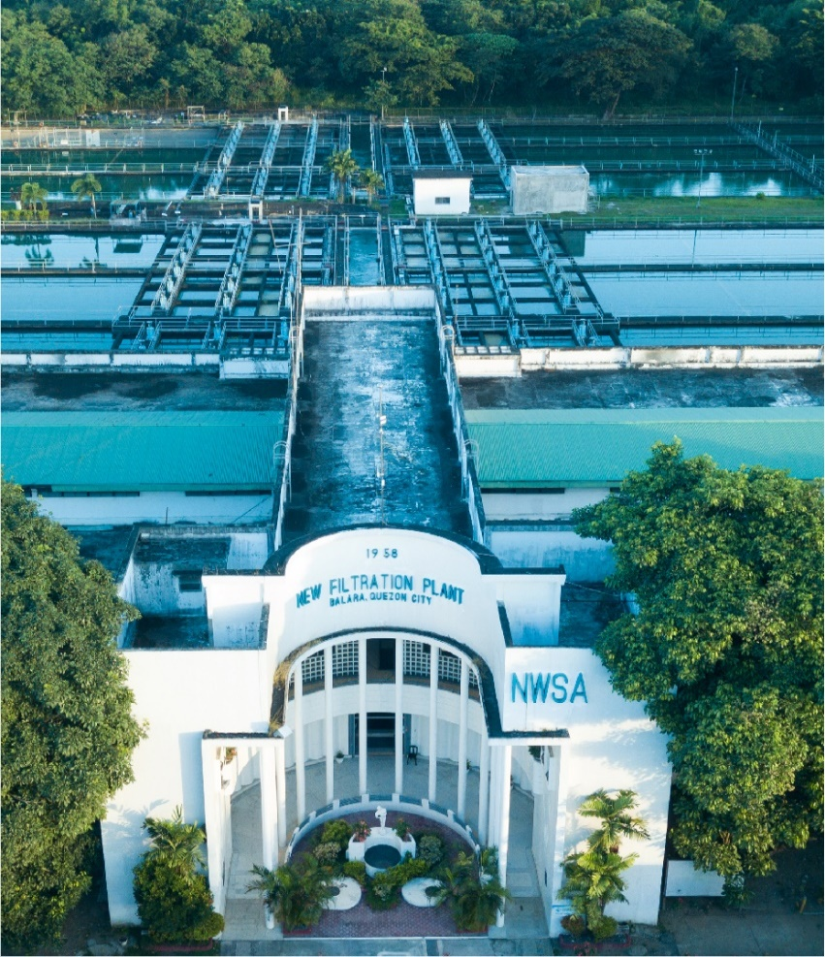



Contents
1 Document Organization 5
1.1 Document Log 5
1.2 Integration, Document Reference 5
2 Program Attributes 6
2.1 Selection Screen 6
2.2 Validation of Selection Criteria 7
2.3 CDS Views/AMDP/Table Function 7
2.3.1 Selection Condition 7
2.3.2 Join Condition 7
2.3.3 Fields 7
2.3.4 Additional Details 7
2.3.5 GIT Repository Details 7
2.4 Authorization Requirements 8
2.4.1 Definition 8
2.4.2 Defined Fields 8
2.4.3 Procedure 8
2.4.4 DCL Details 8
2.4.5 BTP Details 8
2.5 Technical Flow Diagram 8
2.6 UI Details 8
2.6.1 UI Mock Screens 8
2.6.2 Navigations 9
2.6.3 Actions 9
2.6.4 Validations 9
2.6.5 Other Details 10
2.7 Processing Logic 10
2.8 Reusable Code 10
2.9 Messages 10
2.10 Subroutines 11
3 Report Output 11
3.1 Output Method 11
3.2 Main Heading 11
3.3 Sub Heading 11
3.4 Layout / UI Design 11
3.5 Totaling 12
3.6 Sorting 12
3.7 Page Break 12
3.8 Error Handling 12
3.9 Report Header & Footer 12
4 Assumptions in Technical Design 12
5 Open Issues in Technical Design 12
6 Unit Test Results 12
7 Related Documentation 13

Document Organization
This section provides details about this document, previous version(s) of this document and the document(s) referred.

Document Log
Following table mentions the version changes and the processer(s):
Version | Status | Date | Version Created by (Name/E-Mail/Company) | Role | Comments
1.0 | Draft | September 27, 2025 | Sayyad Sarfraz Ali(sayyad.sarfraz@diligentglobal.com) | Author | Initial Draft
2.0 | Reviewed with Comments | September 28, 2025 | Pulkit Kakkar(pulkit.kakkar@diligentindia.onmicrosoft.com) | Reviewer

Integration, Document Reference

S. No. | Referred Document Name | Referred Document Version | Referred Document URL (Optional)
1 | MWC_DID_S2P_355_FS_SOB_Report_20250715 | V1.0 | Attached below under Related Documentation

Program Attributes
Program title | Summary of Billing Process Report
Program Name | ZAB_M2C_SUM_BILL_PROCESS
Program Type | Executable
Package | ZS4_MWC_M2C_BI
Authorization Group | N/A

Transaction Code | ZTR_S2P_SOB
Include Programs | ZIN_M2C_SUM_BILL_PROCESS_TOP.  ZIN_M2C_SUM_BILL_PROCESS_E01.  ZIN_M2C_SUM_BILL_PROCESS_F01.

SAP Tables Read | MMPUR_SES_ITEM  MMPUR_SES_HEADER  EKKO  EKPO  EKKN  LFA1  PRPS  PROJ  AFKO  EKBE  RBKP  RSEG
Custom Indexes | N/A
CDS Views | N/A
OData Service | N/A
Business Object | N/A
Group Name | N/A
Catalog Name | N/A

Selection Screen

Validation of Selection Criteria
- Entered PO must be an Original PO

CDS Views/AMDP/Table Function
N/A

Selection Condition
N/A

Join Condition
N/A

Fields

N/A

Additional Details
N/A

GIT Repository Details

Development Details
GIT Location | N/A
GIT URL | N/A

Authorization Requirements
N/A

Definition
N/A

Defined Fields
N/A

DCL Details
N/A

BTP Details

xs-security Configuration | N/A
IDP Setup | N/A
BTP Role Collections | N/A

Technical Flow Diagram
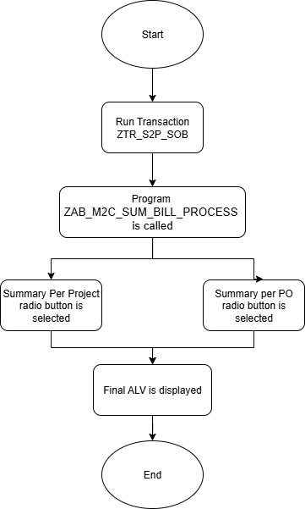

UI Details
N/A

UI Mock Screens

Application Name
Site | N/A
URL | N/A
Mockup | N/A

Navigations

Source View | Target View / URL | Pattern
N/A | N/A | N/A

Actions

Application | Screen(s) | Action | Type | Action Description
N/A | N/A | N/A | N/A | N/A

Validations
Application | Screen(s) | Field/Button | Validation Logic – Method, function details
N/A | N/A | N/A | N/A

Other Details
N/A

Processing Logic
- The program begins by checking which radio button is selected: PO Based or WBS Based.
- If PO Based is chosen, Purchase Order header data is read from EKKO, and the corresponding account assignment details are taken from EKKN.
- If WBS Based is chosen, WBS element details are fetched from PRPS, and linked Purchase Orders are determined through EKKN and EKKO.
Project information such as project definition and description is retrieved from PROJ and PRPS using the WBS element.
- Vendor details (name and other attributes) are collected by combining PO header data (EKKO) with vendor master data from LFA1.
- Purchase Order item information is read from EKPO to calculate the overall contract value and to provide line-level item details.
- For each Purchase Order, invoice data is retrieved:
- Invoice headers are read from RBKP.
- Invoice line items are fetched from RSEG.
- Payment history and related movements are identified through EKBE.
- Using the SES and invoice values, deductions such as advance and retention are calculated along with cumulative billed amounts.
- All financial figures are converted into the reporting currency with the standard currency conversion function to maintain consistency.
- The final output is prepared for ALV display, showing both detailed records and header totals.

Reusable Code
N/A

Messages
N/A

Subroutines
Name | Description
N/A
N/A
N/A

Report Output

Output Method

N/A

Main Heading

Sub Heading
N/A

Layout / UI Design
N/A

Totaling
N/A

Sorting
N/A

Page Break
N/A

Error Handling
N/A

Report Header & Footer
N/A

Assumptions in Technical Design

N/A

Unit Test Results

Scenario # | Input Selection Criteria | Expected Result | Actual Test Pass/Fail
1 | Extract the SOB report per project | The system displays the SOB report for all purchase orders related to the project | Pass
2 | Extract the SOB report per PO | The system displays the SOB report for the selected purchase order | Pass

Related Documentation

